npm uninstall -g appium

npm install -g appium@1.6

NativeApp Automation Guide - Android

**Table of Contents**

1. **Objective**
2. **Scope**
3. **Prerequisites**
4. **Installation**
   1. **Install Ruby**
   2. **Install RubyMine**
   3. **Install SourceTree**
   4. **Install Android Studio**
   5. **Install Appium Server for Windows**
5. **Setup Automation for Frst Use**
   1. **Download codes via SourceTree**
   2. **Create environment variable for script**
   3. **Open code in RubyMine**
6. **Running Automation**
   1. **Running a single script**
   2. **Running All scripts**
   3. **Running with Report generated**
7. **Modify Rspec-Html Class**
8. **SUMMARY**

# Objective

This serves as a reference and guide for resources who want to set-up MIP Automation for Android.

# Scope

The scope of this document would cover the following:

* Prerequisites which includes development kits, applications and system settings
* Installation, Setup and Configuration
* UIAutomatorviewer demo
* Running Automation Script

# Prerequisites

Download and install the ff. (if not yet installed)

* Ruby
* Rubymine – less than version 8
* <https://www.jetbrains.com/ruby/download/#section=windows>
* SourceTree
* https://www.sourcetreeapp.com/
* Android Studio
* Appium Server

# Installation

## Install Ruby

* Go to <https://rubyinstaller.org/downloads/>
* choose the version you would like, and click on the .exe link (under the name of the version) to download the installer
* Use Windows Explorer to navigate to where you saved the .exe file and double-click on it to run the installer.
* Install the following libraries for ruby
* gem install appium_lib
* gem install selenium-webdriver
* gem install csv
* gem install rspec-legacy_formatter
* gem install eventmachine -–platform ruby

## Install RubyMine

* Run the rubymine-2018.2.3.exe file that starts the Installation Wizard
* Follow all steps suggested by the wizard. Please pay special attention to the corresponding installation options

## Install SourceTree

* Go to the [Sourcetree website](https://www.sourcetreeapp.com/) and click the download button.
* From the ZIP file you download, click the application file (EXE for Windows or DMG for Mac) to download.
* After you install, you'll have to agree to the Atlassian Customer Agreement and hit **Continue**.
* You need an Atlassian account to use Sourcetree. When you get to this screen, cick either **Use an existing account** or **Go to My Atlassian**and follow the prompts to [create a new account](https://id.atlassian.com/signup?application=mac&continue=https%3A%2F%2Fmy.atlassian.com%2Fproducts%2Findex). Once you've got an account, you'll be able to log in with **Use an existing account**.
* Follow the prompts until you're done with the setup. If you aren't ready to clone a repository, click **Skip Setup**.

## Install Android Studio

* [download the latest version of Android Studio](https://developer.android.com/studio/).
* If you downloaded an .exe file (recommended), double-click to launch it.

If you downloaded a .zip file, unpack the ZIP, copy the **android-studio** folder into your **Program Files** folder, and then open the **android-studio > bin** folder and launch studio64.exe (for 64-bit machines) or studio.exe (for 32-bit machines).

* Follow the setup wizard in Android Studio and install any SDK packages that it recommends.
* Add in PATH in environment variable the location of sdk\platform-tools
* Create emulator via AVD Manager, then make sure that the name of the emulator is the same with the Appium Capabilities Config.

## Install Appium Server on Windows

* Install Node & NPM
  + Download latest node MSI from nodejs.org and install node. This will also install node’s npm tool (node package manager) which we will use to install Appium Server.

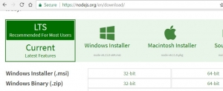

* + Ensure you select to install the npm tools and the system paths:

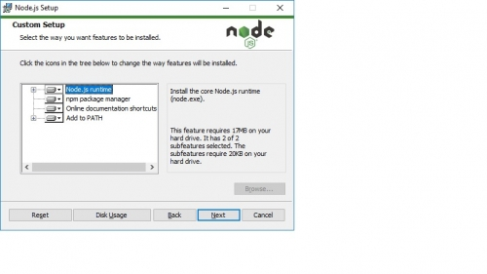

* Install Appium using node’s npm package manager.
  + Open a command prompt as an administrator.
  + Run command ‘npm install -g appium’

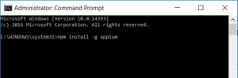

# Set-Up Automation for First Use

## Download codes via SourceTree

* Open sourcetree, click File -> Clone / New

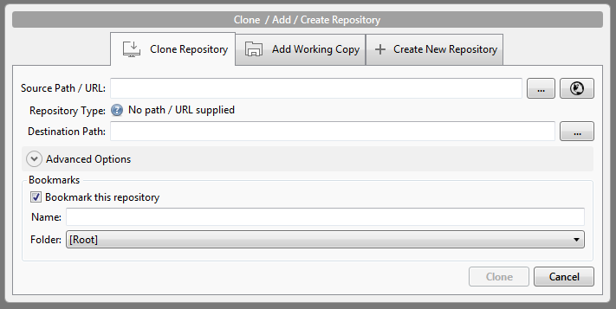

* Add the ff. values:
  + Source Path/URL: <https://github.com/GameStopCorp/gs.automation.androidapp>
  + Destination Path: C:\dev\gs.automation.androidapp

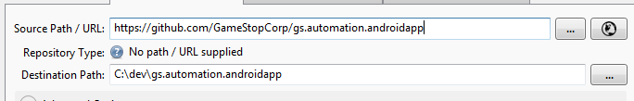

* Click ‘Clone’ button, if prompted for user account use your github account
* Create a local copy of **dev** branch

## Create environment variable for script

* Go to Control Panel\System and Security\System, click ‘**Advance system settings**’
* On System Properties -> Advanced tab, click ‘Environment variables’ button
* Select New, then add the ff. on the fileds
  + Variable name: android_scripts
  + Variable value: C:\dev\gs.automation.androidapp\Scripts

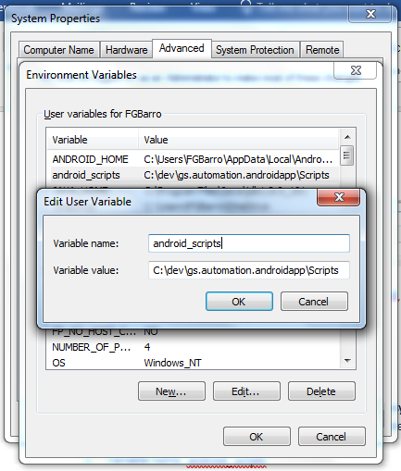

## Open code in RubyMine

* Launch Rubymine, click ‘File’ -> ‘Open’
* Browse to C:\dev\gs.automation.androidapp, then hit ‘OK’

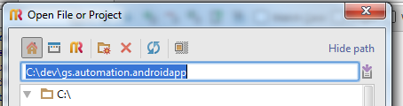

# Running Automation

## Running a single script

* Open command line, enter the ff. command

‘rspec %android_scripts%\spec\**\*_spec.rb -e ‘example name’

or

‘rspec %android_scripts%\spec\**\*_spec.rb -t ‘testcase name’

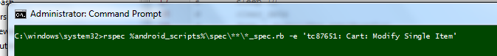



## Running All scripts

* Open command line, enter the ff. command

‘rspec %android_scripts%\spec\**\*_spec.rb

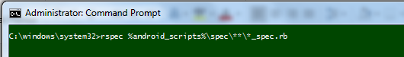

## Running with Report generated

* Open command line, enter the ff. command

‘rspec %android_scripts%\spec\**\*_spec.rb -f RspecHtmlFormatter’

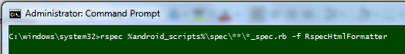

# Modify Rspec-Html Class

* Open project in RubyMine
* Locate the file rspec_html_formatter.rb. (Usually in C:\Ruby24-x64\lib\ruby\gems\2.4.0\gems\rspec_html_formatter-0.3.1\lib\rspec_html_formatter.rb)



* Change the value for REPORTH_PATH into "C:/Users/Public/android_output/rspec_html_reports/#{Time.now.strftime('result__%d_%m_%Y__%H_%M')}"



# SUMMARY

With All things above performed, you should be all set to run automation or create your scripts.